Birds, bees and bugs: your garden is an ecosystem, and it needs looking after

As the weather warms and days lengthen, your attention may be turning to that forgotten patch of your backyard. This week we’ve asked our experts to share the science behind gardening. So grab a trowel and your green thumbs, and dig in.
Whether you live in an urban apartment or a rural homestead, your outdoor area is more than just a private space. Ecologically, a garden is another jigsaw piece in the landscape.
Whatever their size, gardens can contribute to natural functions and processes in the local area, such as regulating water drainage, buffering the damaging effects of strong winds, or providing food and shelter for native wildlife.
Many wildlife species survive in urban areas, but their presence and persistence depend on how specific their food and shelter needs are, how they respond to disturbances, and the quality and quantity of other green spaces in the landscape.
For larger animals, such as birds and mammals, a home garden could become a stepping stone across an otherwise hostile urban landscape. For smaller animals, such as insects, it could be the centre of their home range.
In urban areas, where space is often limited, gardening with pollinators in mind is a simple way to encourage biodiversity in the backyard. And, depending on the surrounding landscape, habitat for pollinators will also be habitat for other animals.

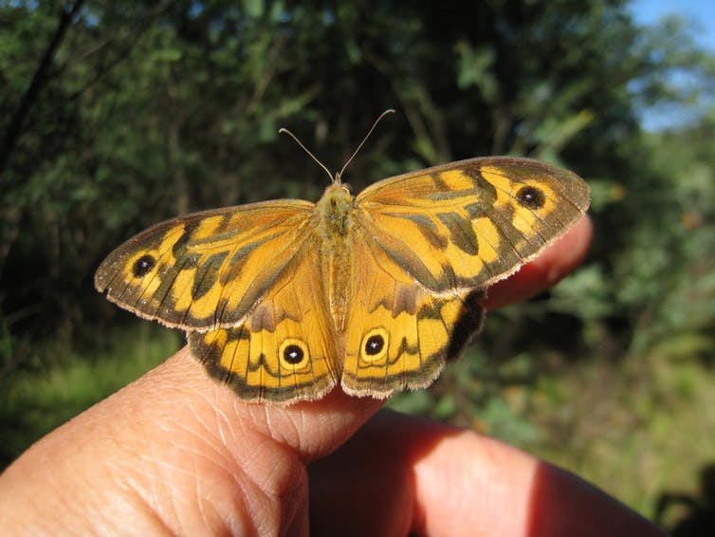
Butterflies are important pollinators in backyards. John Tann/Flickr, CC BY

Flowers are just the first step
Flowers produce sugar (nectar) and protein (pollen), the main diet for many adult insects and birds. Unlike other insect groups, native bee larvae develop almost exclusively on pollen collected by their parents, so flowers are essential to grow native bee populations.
There is no single best combination of flowers for wild bees. Many “plants for pollinators” lists available online are based on local experiences and rarely apply to all geographic regions. A general rule of thumb for a pollinator garden is one that produces flowers for most of the year and is built on diversity – monocultures of any single flower type or colour will suit only a very small number of generalist species.
Native plants are an ideal option for attracting native pollinator insects and birds, but many garden exotics, especially herbs, fruit and vegetable plants, are just as popular. Modern hybrid varieties should be chosen carefully, as some are bred for commercial fruit or flower traits (like size or colour), but the flowers lack the nectar or scent cues that attract pollinators looking for food.

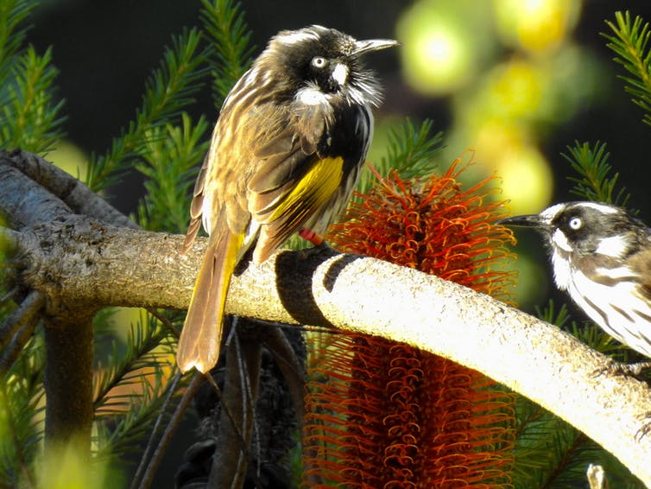
Native plants can attract birds, such as this New Holland honeyeater. Cazz/Flickr

Build it and they will come
The structure and design of a garden can determine what wildlife species will visit or make a home. Vertical structure, built from multiple layers of different plant heights, provides more spaces for wildlife to co-exist. Small plants and shrubs provide good shelter for insects and very small birds, while larger trees will attract visits from more mobile birds and mammals.
Large trees with rough or shedding bark that creates lots of cracks and crevices are excellent shelter for insects and small lizards. Trees that produce resins and sap flows, such as conifers, acacias and eucalypts, are also useful for some native bee and wasp species that use resin to seal their nest cells.
Insect hotels can provide homes for insects that usually nest in dead wood. But only a small proportion of the world’s bee species are wood-nesters. About 75% of bee species dig their nests into the ground, usually in sandy, uncompacted soil, preferably on a slope that won’t get waterlogged.

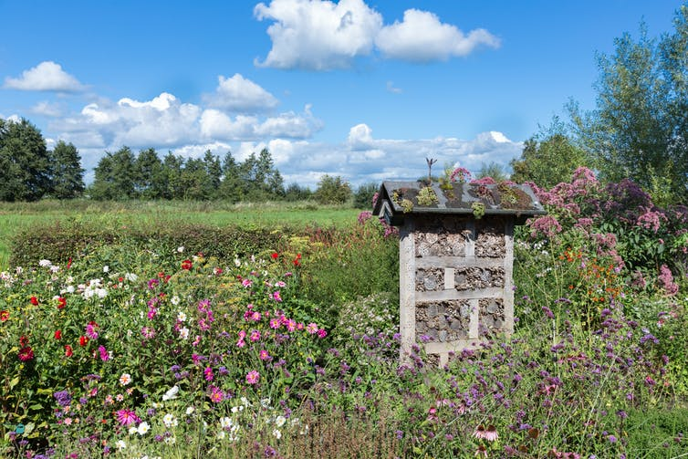
Insect hotels attract wood-nesting insects. Insect hotel image from www.shutterstock.com

It can be difficult to build all of this into small gardens, but many pollinator insects will have home ranges of a few hundred metres, while birds and mammals can travel much further. So landscape composition can also influence the wildlife potential of an individual garden. A high proportion of paved areas can reduce the number of wild bees or native birds in the neighbourhood. Highly manicured green spaces can also have a negative effect on wild bee species.

Disrupting the food chain
Like any ecosystem, gardens involve an intricate web of life, from the soil microbes underground to the birds in the trees. It’s easy to grab the spray bottle to kill off the dandelions and blow down the flies, but what are the knock-on effects?
Many of the animals and plants we think of as a backyard nuisance often provide services we don’t see. For example, many native wasp and fly species (even blowflies!) are pollinators as adults. And as larvae, they control many of the insect pests we see on our plants, or decompose organic wastes. Small reptiles, like geckoes and skinks, mostly feed on small insects that annoy us, like mosquitoes and midges.
Plants we think of as lawn weeds, particularly dandelions and clover, are a favourite food source for native bees and hoverflies. Aphids and scale insects also produce a sugary substance called honeydew as they suck on plants, which is an important sugar source for some beneficial insects like wasps, bees, ants and hoverflies.


Author: Manu Saunders is a Post-doctoral Research Fellow (Ecology), Charles Sturt University
Disclosure statement
Manu Saunders is affiliated with the Institute for Land Water & Society and is co-founder of the Wild Pollinator Count.

